**We will cover following topics:**

- Azure – Components

- Module

- Fabric Controller

**Azure - Components**

## Compute / Execution Models

This is the interface for executing the application, which is one of the basic functions of Azure.

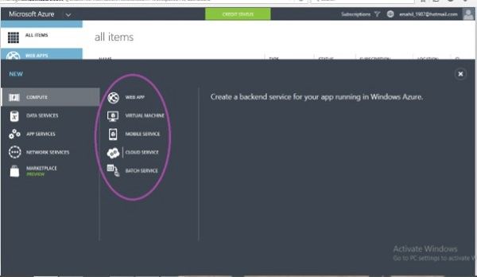

As seen in the above image, there are different models such as **Web App, Virtual Machine, Mobile Service, Cloud Service, and Batch Service**. These models can be used either separately or in combination as per the requirement.

## Data Management

**RDBMS (Relational): MS SQL Server**

Data management can be done by using SQL **server Database component** or the simple data storage module offered by Windows Azure. SQL server database can be used for relational database.

**File System (Blobs): Image, Folder, Vedio, Audio etc.**

The storage module can store unrelated tables (without foreign key or any relation) and blobs. ***Blobs include binary data in the form of images, audio, video, and text files***.

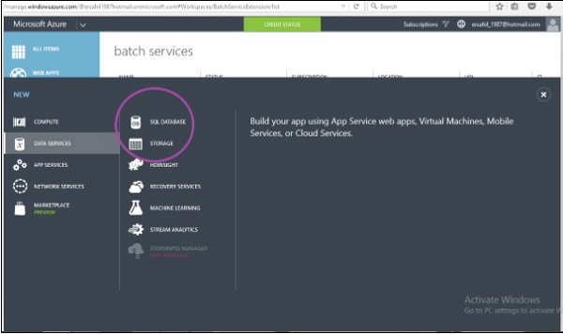

## Networking

Azure traffic manager routes the requests of a user intelligently to an available datacenter.

The process involves finding the nearest datacenter to the user who makes the request **for web application, and if the nearest datacenter** is not available due to various reasons, **the traffic manager deviates the request to another datacenter**.

However, rules are set by the owner of the application as to how a traffic manager should behave.

The virtual network is another feature that is part of networking in services offered by Windows Azure. The virtual network allows a network between local machines at your premise and virtual machine in Azure Datacenter. IPs to virtual machines can be assigned in a way that makes them appear to be residing in your own premise. The virtual network is set up using a Virtual Private Network (VPN) device.

The following image shows how these two features actually look in Azure portal.

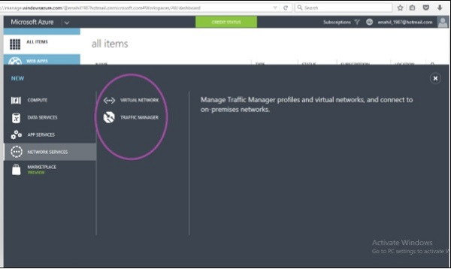

## Big Data and Big Compute

Combination of **structured (relational), semi-structured (file system: .csv, .xls, .txt, .dat etc), and non-structured (media data : vedio, audio, images etc)** data over the cloud i.e. Big data concept. Data beyond data is known big data.

Platform:

* Hadoop
* Teradata
* SAP HANA

Etc.

The large amount of data can be stored and managed using Windows Azure. Azure offers HDInsight which is Hadoop-based service. Organizations often need to manage large amount of data which is necessarily not relational database management. Hadoop is a prominent technology used these days. Thus, Azure offers Hadoop service on their platform for clients.

The term ‘Big Compute’ refers to high performing computations. This is achieved by executing code on many machines at the same time.

## Messaging

Windows Azure offers two options for handling the interactions between two apps.

One falls under **storage component** of the service and is called **'Message Queues'**.

The other one comes under the **app service** and is called **'Service Bus'**.

The messages can be sent to initiate communication among different components of an application or among different applications using these two options.

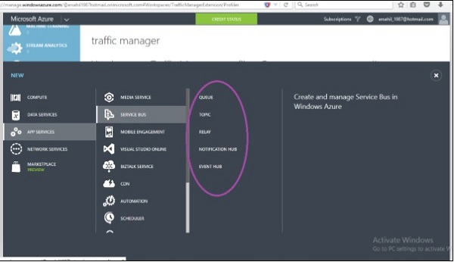

## Caching

Microsoft Azure offers two kinds of caching which **are in-memory Caching** and **Content Delivery Network (CDN)** for caching frequently accessed data and improves the application performance.

CDN is used to cache the blob data that will be accessed faster by users around the world.

## Identity and Access (GUID)

This component is about management of users, authentication and authorization. Active directory stores the information of users accessing the application and also the organization’s information. It can synchronize with the related information on local machines residing on premises. Multifactor Access (MFA) service is built to address the security concerns such as only the right user can access the application.

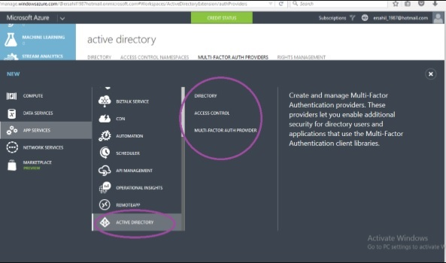

## Mobile Service

Windows Azure offers a very easy platform to develop mobile application. You can simply start using mobile development tools after logging into your account. You don’t have to write big custom codes for the mobile application if you use this service. The push notifications can be sent, data can be stored and users can be authenticated in very less time.

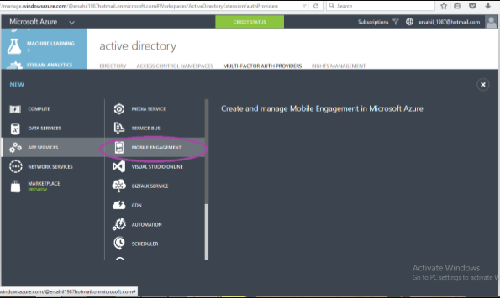

## Backup

The site recovery service replicates the data at secondary location as well as automates the process of recovery of data in case of data outage.

Similarly Azure backup can be used to backing up the on premise data in clouds. Data is stored in encrypted mode in both the cases. Windows Azure offers a very effective and reliable backup service to clients and ensures they don’t face inconvenience in case of hardware failures.

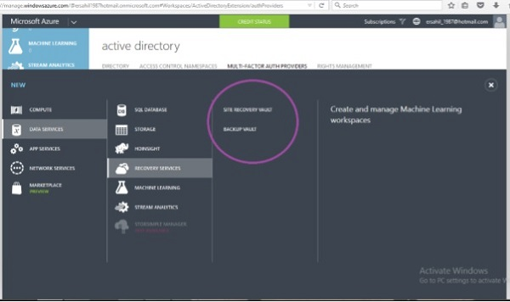

## Media

This service addresses multiple concerns related to uploading media and making it available to end users easily. Users can manage tasks related to the media like encoding, ad insertion, streaming, etc. easily.

## Commerce

Windows Azure offers the opportunity to users to buy or sell applications and data through their platform. The applications are put in the marketplace or Azure store from where they can be accessed and bought by other users.

## Software Development Kit (SDK)

Azure applications can be produced by the developers in various programming languages. Microsoft currently provides language-specific SDKs for Java, .NET, PHP, Node.js, Ruby, and Python. There is also a general Windows Azure SDK that supports language, such as C++.

# Compute Module

**Step 1** − First, login in to your Azure account.

**Step 2** − Click ‘New’ at the left bottom corner and drag your cursor to ‘Compute‘.

Now you will see a list of models under Compute Model as shown in the following image.

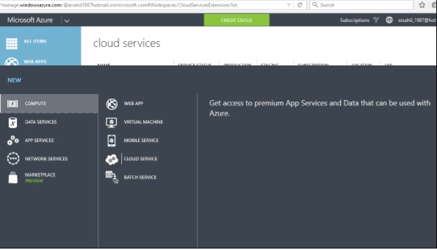

## Create a Web App

**Step 1** − Click Web App.

**Step 2** − Click Quick Create and enter the URL and choose a service plan from the dropdown list as shown in the following image.

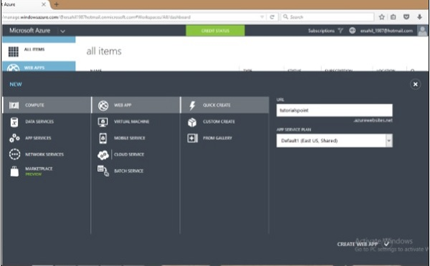

When you go back to the main screen, it will show the website just created. And when you click the website URL, it will take you to the website.

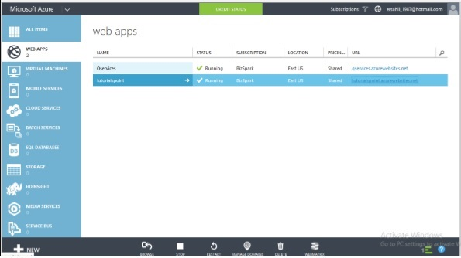

The following image shows how your website will look when you click the URL.

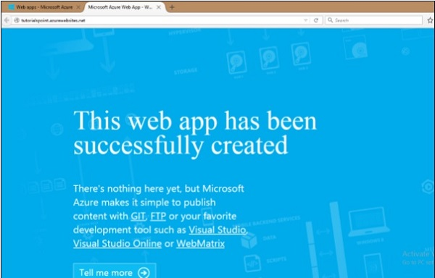

Similarly, you can choose ‘From Gallery’ when creating a web app instead of ‘Quick Create’. This will let you choose the development framework in which you want to create your app.

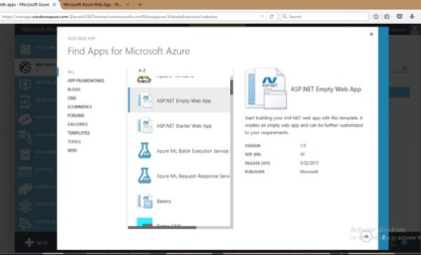

Windows Azure supports .Net, Java, PHP, Python, Node.js and Ruby. There are several ways of publishing the code to Azure server. It can be published using FTP, FTPs, Microsoft Web Deploy technology. Various source control tools such as GitHub, Dropbox and Codeplex can also be used to publish the code. It provides a very interactive interface to keep track of changes that have been published already and also unpublished changes.

## Create a Virtual Machine

**Step 1** − Click on ‘Virtual Machine’ from the list.

**Step 2** − Then click ‘From Gallery’.

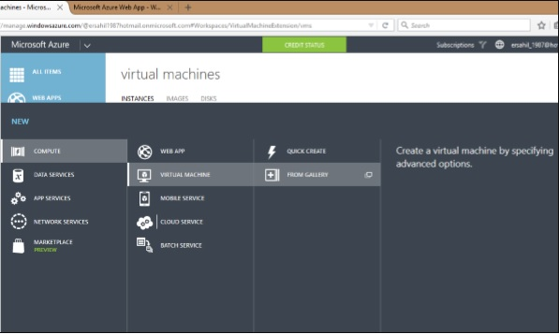

**Step 3** − Choose the Operating System or Program you want to run.

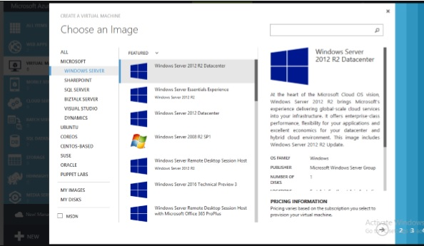

**Step 4** − Choose the configuration and fill in the details.

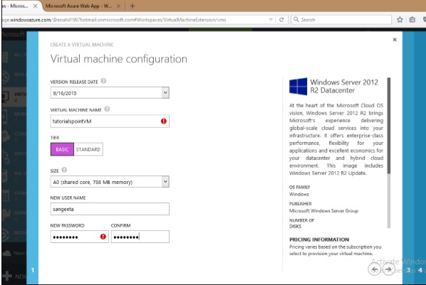

The Username and Password you set up here will be needed to access the virtual machine every time.

On the next two screens you can leave the default values on for the first time.

**Step 5** − The virtual machine just created will be displayed when you click on ‘Virtual Machine’ on the left panel as shown in following image. It might take a few minutes to show up.

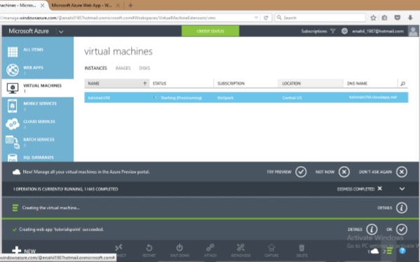

**Step 6** − Once the machine is created you can connect to it by clicking on the connect icon displayed at the bottom of the screen. It will save a .rpd file on your machine as shown in the following image. Chose ‘save file’ on the screen and it will save in ‘downloads’ or the in the set location on your machine.

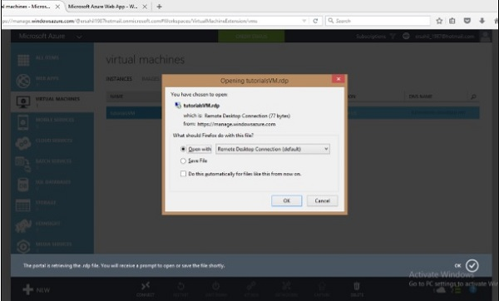

**Step 7** − Open that .rpd file and you can connect to the VM by filling in the credentials into the following screen.

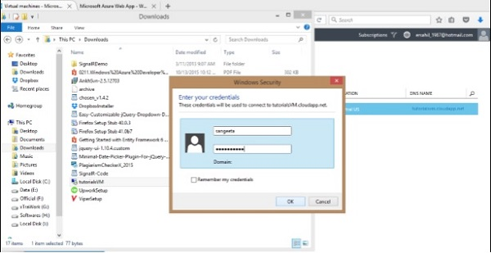

You can also use your own image by capturing the image of an existing virtual machine or virtual hard drive. Virtual machines are beneficial in several ways.

* A user can try new operating system without actually installing them.
* A VM can be deleted when you are done with the operating system.
* New versions of an operating system can be tried and tested before the user installs them on the machine.
* VM provides a very economical and hassle free way of using a development framework or a tool that runs on specific version of OS.

## Creating a Mobile Service

Mobile services compute hosting model is optimized to provide a cloud backend for applications that run on mobile devices. For creating a mobile service −

**Step 1** − Select Mobile services under Compute and click on create. A new window will be open as shown in the following image.

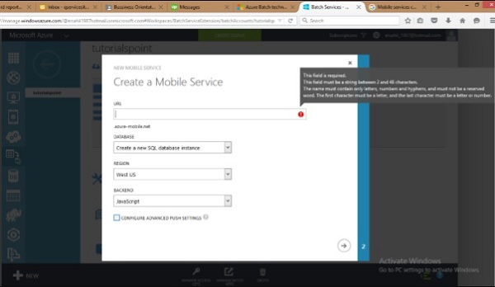

**Step 2** − Fill in the URL. Select the database, region and backend.

**Step 3** − Tick the check box if you want to configure the advance push settings. This option allows us to configure our Mobile Service to use an existing notification hub or specify the name of a new one. If you leave this checkbox unmarked, a new hub will be created in a new namespace with a default name.

## Creating Batch Service

Batch service is needed when a large scale application is run and a parallel high performing computing is required. The developers can create batches to run a task parallel that eases the workload at no extra cost. Azure charges for only the virtual machines which are being used. They can schedule a task, put them in queues and manage the workload in cloud. Batch creation does not involve setting up a separate VM, cluster or job scheduling.

To creating a batch service follow the similar steps for creating other services under Compute model. The following image shows how a batch service can be created quickly.

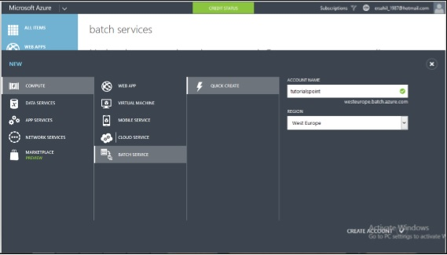

Once you have created a batch service, you can see the details by selecting it from the left panel. The following image pops up on the screen.

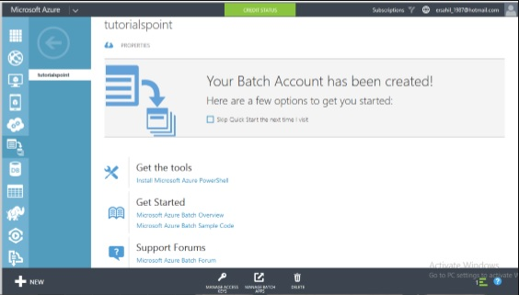

# Fabric Controller

Fabric Controller is a significant part of Windows Azure architecture. When thinking of the components or services provided by Windows Azure, we wonder how all this works and what is happening in clouds. It seems very complex from our end. Let us look into the physical architecture of these services to have a better understanding of Fabric Controller.

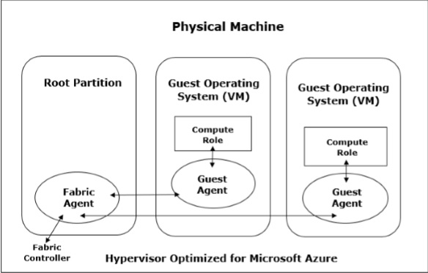

Inside the datacenter, there are many machines or servers aggregated by a switch. We can say that fabric controller is a brain of the azure service that analyses the processes and makes decisions.

**Fabrics** are group of machines in Microsoft’s datacenter which are aggregated by a switch. The group of these machines is called **cluster**.

Each cluster is managed and owned by a fabric controller. They are replicated along with these machines. It manages everything inside those machines, for e.g., load balancers, switches, etc. Each machine has a fabric agent running inside it and fabric controller can communicate with each fabric agent.

When selecting a virtual machine offered by Windows Azure services, there are five options to choose from. The configuration is as follows −

|  |  |  |  |
| --- | --- | --- | --- |
|  | **Memory** | **CPU** | **Instance Storage** |
| **Extra Small** | 768 MB | Single core 1.0 GHz | 20 GB |
| **Small** | 1.75 GB | Single core 1.6 GHz | 225 GB |
| **Medium** | 3.5 GB | Dual core 1.6 GHz | 490 GB |
| **Large** | 7 GB | Four core 1.6 GHz | 1,000 GB |
| **Extra Large** | 14 GB | Eight core 1.6 GHz | 2,040 GB |

When a user chooses one of the virtual machine, the operating system, patch updates and software updates are performed by fabric controller. It decides where the new application should run which is one of the most important functions of Fabric Controller. It also selects the physical server to optimize hardware utilization.

When a new application is published in Azure, an application configuration file written in XML is also attached. The fabric controller reads those files in Microsoft datacenter and makes the setting accordingly.

In addition to managing the allocation of resources to a specific application, it also monitors the health of compute and storage services. It also makes the failure recoveries for a system.

Imagine a situation where four instances of web role are running, and one of them dies. The fabric controller will initiate a new instance to replace the dead one immediately. Similarly, in case any virtual machine fails, a new one is assigned by the fabric controller. It also resets the load balancers after assigning the new machine, so that it points to the new machine instantaneously. Thus, all the intelligent tasks are performed by the Fabric Controller in Windows Azure architecture.